Adriana Rodriguez

11/12/23

CSD 310 Module 5.2 Assignment

###### **Assignment: MySQL Functions**

Go out to the W3Schools links above, and select at least three functions to experiment with. For each:

1. MYSQL UPPER() Function

Provide an explanation of when it might be used: Used to convert the text to upper-case.

Provide an appropriate alias for the column header in the results: UppercaseText

Provide the SQL statement, run the statement, then take a screenshot of the results:

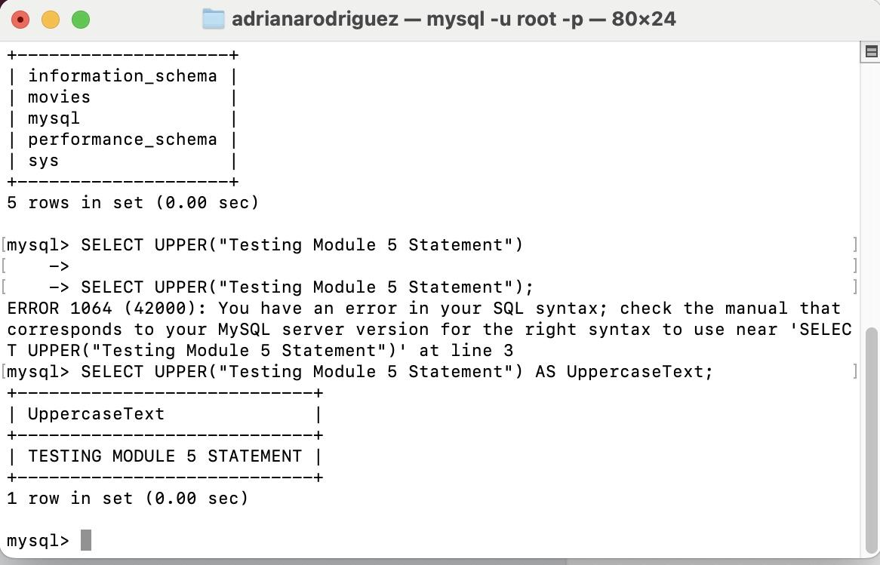

1. MYSQL REPEAT() Function

Provide an explanation of when it might be used: Repeats the string as many times as specified.

Provide an appropriate alias for the column header in the results: REPEAT (“Testing Module 5 Statement”, 5)

Provide the SQL statement, run the statement, then take a screenshot of the results:

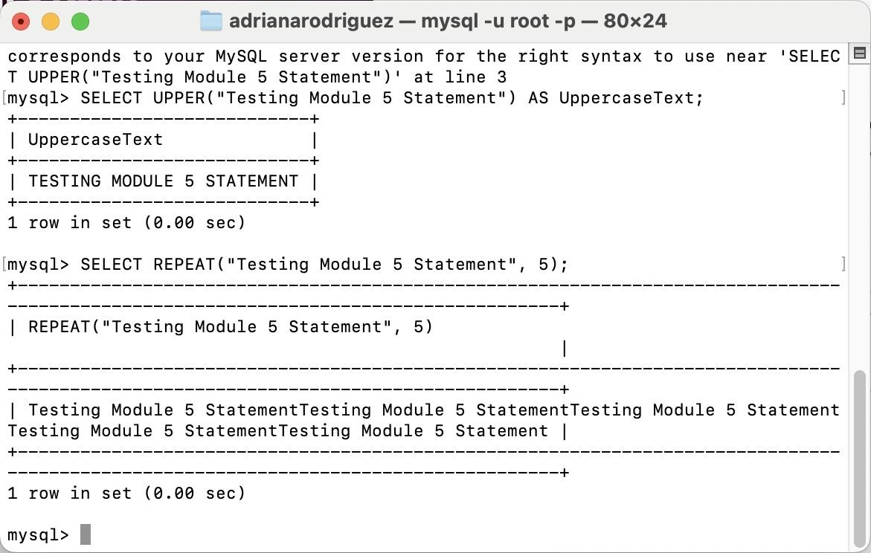

1. MYSQL POSITION() Function

Provide an explanation of when it might be used: Returns the position of the first occurrence of a substring in a string.

Provide an appropriate alias for the column header in the results: MatchPosition

Provide the SQL statement, run the statement, then take a screenshot of the results:

